**LocalInsight AI**

Sumit Samanta

07/09/2024

*Abstract*

**LocalInsight AI** is an AI-driven platform designed to empower small businesses with deep insights into their local markets. By analyzing customer demographics, preferences, and competitors within a specific area, **LocalInsight AI** helps businesses make informed decisions. Using machine learning components such as clustering algorithms for customer segmentation, sentiment analysis to evaluate competitor reviews, and demand forecasting tailored to the business's location and industry, **LocalInsight AI** provides actionable recommendations. This allows businesses to optimize their strategies, cater to local demands, and stay ahead of their competition

**1.Problem Statement:**

Small businesses often struggle to understand their local market dynamics, including customer demographics, preferences, and competitive pressures. Traditional market research methods are time-consuming, costly, and may not provide the level of insight needed for effective decision-making. Without actionable data, businesses face challenges in segmenting their customers, evaluating competitor strengths and weaknesses, and forecasting demand trends. This lack of local market understanding can lead to missed opportunities, inefficient resource allocation, and an inability to adapt to changing market conditions, ultimately affecting profitability and growth.

LocalInsightAIaims to address these challenges by leveraging machine learning to provide small businesses with accurate, data-driven insights into their local market, enabling them to optimize their strategies and thrive in competitive environments.

**2. Market/Customer/Business Need Assessment:**

**2.1 Market Analysis:**

Small businesses operate in highly localized and often competitive environments, where understanding customer needs and competitor dynamics is crucial for success. In many cases, these businesses lack access to sophisticated market analysis tools that can provide insights into local trends. Traditional market research is either too expensive or doesn't offer the granular, real-time data needed for smaller businesses to make informed decisions.

With the rise of data-driven decision-making in larger enterprises, there is an increasing need for small businesses to adopt similar strategies to remain competitive. However, small business owners often face difficulties in collecting, analyzing, and interpreting vast amounts of local data, including customer demographics, preferences, and competitor performance. This gap leaves many businesses unable to optimize their offerings, tailor their marketing strategies, or predict changes in demand effectively.

**LocalInsight AI** taps into this unmet need by offering a cost-effective, AI-powered platform that delivers actionable market insights tailored to small businesses. Using machine learning models like clustering algorithms for customer segmentation, sentiment analysis for competitor reviews, and demand forecasting, **LocalInsight AI** provides small businesses with the tools they need to thrive in their specific markets. As local markets continue to evolve with changes in consumer behaviour and competitive pressures, **LocalInsight AI** positions itself as a valuable tool to help small businesses grow and adapt effectively.

**2.2** **Customer Segmentation :**

**Customer Segmentation** is a core feature of **LocalInsightAI**, designed to help small businesses categorize their customers into distinct groups based on shared traits, preferences, and behaviors. This segmentation enables businesses to craft personalized strategies, optimize their product offerings, and tailor marketing efforts to better meet the needs of each customer group.

Through machine learning-driven clustering algorithms, **LocalInsightAI** analyzes data such as demographics, purchase history, location, and behavioral patterns to create meaningful customer segments. These segments typically include:

1. **Demographic Segmentation**: Customers are grouped based on attributes like age, gender, income, and education level, helping businesses understand who their primary customers are.
2. **Behavioural Segmentation**: This includes classifying customers by their shopping habits, frequency of purchases, product preferences, and brand loyalty, allowing businesses to identify high-value or frequent buyers.
3. **Geographic Segmentation**: Customers are grouped based on their location, proximity to the business, or neighbourhood trends, enabling businesses to focus efforts on specific geographic areas.
4. **Psychographic Segmentation**: This approach looks at customers' lifestyles, interests, and values, helping businesses align their offerings with the attitudes and motivations of different customer groups.

**3.External Search:**

AI-powered tools like **LocalInsight AI** are transforming how small businesses conduct local market analysis. By leveraging machine learning techniques, businesses can gain real-time insights into customer demographics, behaviour, and competitor analysis. One key component is customer segmentation through clustering algorithms, which groups customers based on shared characteristics, enabling personalized marketing strategies that target the right audience. Additionally, sentiment analysis can assess competitor reviews, while demand forecasting predicts market trends, allowing businesses to adapt and optimize their operations for improved efficiency and ROI.

AI's ability to process vast amounts of data quickly also ensures that insights are accurate and timely, helping businesses stay competitive in their local markets. However, data quality, privacy, and algorithm bias are important considerations that must be managed carefully to ensure ethical and effective analysis.

**4. Bench marking alternate products:**

1. HubSpot – Marketing Hub

HubSpot offers tools for marketing automation, customer segmentation, and CRM integration. It’s great for broader digital marketing but lacks the localized focus of LocalInsightAI, which is tailored specifically for small businesses.

2. Semrush – Market Research Tool

Semrush is ideal for SEO and online competitor analysis. It excels in digital presence optimization but is more suited to web-based businesses rather than localized market analysis like LocalInsightAI.

3. Clearbit – Data Enrichment Platform

Clearbit focuses on enhancing CRM data with demographics and firmographics, providing personalized marketing insights. However, it lacks geographical specificity, which LocalInsightAI offers for local businesses.

4. Nexis DaaS – Market Intelligence

Nexis DaaS provides large-scale market intelligence from diverse sources like social media and news. While powerful for global insights, LocalInsightAI is more focused on local competitors and customer behavior.

**5.Regulations and constrains:**

**1. Data Privacy Regulations**

LocalInsightAI will handle sensitive customer data, such as demographics and behaviours. Compliance with **data privacy laws** like the **General Data Protection Regulation (GDPR)** in Europe, **California Consumer Privacy Act (CCPA)** in the U.S., or similar regional laws is critical. These laws regulate how customer data is collected, processed, and stored, ensuring customer consent and the right to access or delete personal data.

**2. AI Transparency and Accountability**

As AI is used for market segmentation and competitor analysis, ensuring transparency in AI decision-making is crucial. Governments and organizations emphasize the need for explainable AI to avoid biased decision-making. Ensuring AI models are fair and free from bias (e.g., not discriminating based on ethnicity, age, etc.) will be a key constraint.

**3. Ethical Considerations**

Using AI for customer profiling and segmentation may lead to ethical concerns. It’s important to avoid overly intrusive profiling practices that might cause harm or violate customers' trust. EthicalAIuse, ensuring fairness and maintaining consumer trust, should be an essential part of the product development process.

**4. Third-party Data and API Licensing**

LocalInsightAI will likely rely on external APIs or third-party data sources for competitor analysis and customer insights. Compliance with data licensing agreements and ensuring that all data use follows the terms set out by the third-party providers is essential to avoid legal challenges.

**5. Advertising and Marketing Regulations**

When LocalInsightAI delivers personalized marketing strategies, it must comply with regulations around digital advertising, including CAN-SPAM Act (for email marketing in the U.S.) and Telemarketing Sales Rule (TSR) to ensure marketing practices do not breach regulatory requirements.

**6.Monitization Strategies:**

**1. Subscription Model**

This is the most reliable way to generate recurring revenue. Offering tiered subscription plans with different levels of access (e.g., basic insights in the lower tier and advanced analytics in higher tiers) ensures you can serve businesses of all sizes. This model guarantees a steady income stream as users subscribe for ongoing local market analysis.

**2. Freemium Model**

A freemium model allows users to try basic features for free while incentivizing them to upgrade to paid plans for advanced tools, such as detailed competitor insights and demand forecasting. It attracts a larger user base and can convert them into paying customers as they see the value in premium features.

**3. Pay-Per-Report**

This model allows small businesses to pay for individual reports as needed, making it more affordable for them while still generating revenue for LocalInsightAI. Offering on-demand reports for customer segmentation, competitor analysis, or market trends could appeal to businesses with specific one-time needs.

**4. API Access Licensing**

Provide API access to larger businesses or third-party platforms that want to integrate LocalInsightAI's insights into their own systems. You can charge based on the number of API calls, making this a scalable and flexible model that can grow with your user base.

**5. Consulting Services**

In addition to the automated insights from the platform, offering personalized consulting services for businesses that need help interpreting the data or applying it to their strategies can be a valuable revenue stream. Businesses can pay for custom reports, workshops, or tailored advice based on the platform's insights.

**7. Final Product Prototype:**

**LocalInsightAI** is an AI-powered local market analysis tool designed to help small businesses gain actionable insights into their local market. The platform leverages machine learning techniques to provide real-time customer segmentation, competitor analysis, and demand forecasting. By analyzing customer demographics, preferences, and competitor behaviors in a specific geographical area, **LocalInsightAI** helps businesses optimize their marketing strategies, enhance customer engagement, and anticipate market trends.

Key features include:

* **Customer Segmentation**: Uses clustering algorithms to group customers based on demographic and behavioral patterns.
* **Competitor Analysis**: Provides insights from competitor reviews using sentiment analysis to gauge strengths and weaknesses.
* **Demand Forecasting**: Predicts future market trends to help businesses make data-driven decisions

**Schematic Diagram**

Below is a simplified schematic diagram for **LocalInsightAI**:

1. **Data Collection Layer**
   * **Customer Data**: Demographics, purchasing behavior, and location.
   * **Competitor Data**: Review scraping from platforms like Google, Yelp, and social media.
   * **Market Data**: Local demand patterns, business trends, and economic factors.
2. **Data Processing Layer**
   * **Data Cleaning**: Removes noise and irrelevant data points.
   * **Feature Extraction**: Extracts key variables for segmentation and analysis.
3. **AI & Machine Learning Algorithms**
   * **Clustering (for Segmentation)**: K-means or DBSCAN to group customers.
   * **Sentiment Analysis**: NLP models to analyze competitor reviews.
   * **Demand Forecasting**: Time series forecasting models like ARIMA or LSTM.
4. **Insight Generation Layer**
   * **Customer Segmentation**: Identifies target audiences for personalized marketing.
   * **Competitor Analysis Dashboard**: Displays sentiment insights from competitor reviews.
   * **Demand Forecast Dashboard**: Shows predicted demand over time.
5. **User Interface Layer**
   * **Business Dashboard**: Visualizes all insights (segmentation, competitors, forecasts).
   * **Reports & Recommendations**: Provides actionable steps based on insights.

**8.** **Conclusion:**

**LocalInsightAI** is designed to be a valuable tool for small businesses, offering AI-driven insights into their local markets. By leveraging customer segmentation, competitor analysis, and demand forecasting, the platform helps businesses make data-driven decisions tailored to their specific geographic and industry needs. The integration of machine learning algorithms like clustering and sentiment analysis ensures that businesses can stay competitive and responsive to local market trends. Through a user-friendly dashboard, **LocalInsightAI** empowers business owners with actionable insights, improving customer targeting, enhancing competitive positioning, and driving business growth.

**Final Product:**

Our product is an advanced data analysis tool that combines a user-friendly **frontend** and a robust **backend** to deliver powerful insights. The **frontend interface** is designed to take user inputs, such as file uploads and specific analysis preferences, ensuring an intuitive and seamless experience. Users can select from a range of analytical options, including **Descriptive Analytics** to summarize their dataset, **K-Means Clustering** for grouping data points into meaningful clusters, and **PCA (Principal Component Analysis)** for dimensionality reduction and uncovering significant patterns in the data. The **backend** is meticulously coded to process the user’s data and perform the requested operations efficiently, returning actionable insights and visualizations. With this integrated system, users can analyze their data dynamically and interactively, empowering them to make informed decisions based on their chosen analysis options.

• **User-Friendly Frontend Interface**: The product boasts a sleek and intuitive frontend designed to simplify the data analysis process for users. It allows users to seamlessly upload their datasets and specify their desired analysis options through an interactive form. The interface includes clear labels, dropdown menus, and input fields, ensuring a smooth user experience even for those with minimal technical expertise.

• **Dynamic Analytical Options**: Users can choose from three powerful analysis techniques tailored to meet diverse data needs:

* **Descriptive Analytics**: Provides a comprehensive summary of the dataset, highlighting key statistical insights like mean, median, variance, and correlations.
* **K-Means Clustering**: Enables users to group data points into clusters, uncovering hidden patterns and relationships within the data. Users can specify the number of clusters for precise control over the analysis.
* **Principal Component Analysis (PCA)**: Reduces data dimensions while retaining its most critical features, allowing users to visualize and interpret high-dimensional data efficiently.

• **Robust Backend Processing**: The backend is expertly coded to handle data preprocessing, analysis execution, and result generation with high efficiency. It is optimized to process user-uploaded files, manage various data formats, and deliver accurate outputs promptly. Each analysis option is powered by reliable algorithms to ensure trustworthy results.

• **Interactive Outputs and Visualizations**: The product delivers insightful visualizations and reports based on the chosen analysis. Users can view and download clustering visualizations, PCA plots, and detailed descriptive reports. These outputs are designed to be clear and actionable, making complex data insights accessible to users of all levels.

• **Seamless Integration and Customization**: The system integrates the frontend and backend seamlessly, providing a cohesive experience from input to output. It offers users the flexibility to tailor their analysis by entering specific parameters like the number of clusters for K-Means or the number of components for PCA. The tool adapts to diverse datasets and user requirements, making it a versatile solution for data-driven decision-making.

Frontend:

The user can put the selctive input values according to him as what kind of analysis he wants .as u can see upload an process button if u click that the data would be cleaned by the machine and be ready tu fit in the model for anlysis .

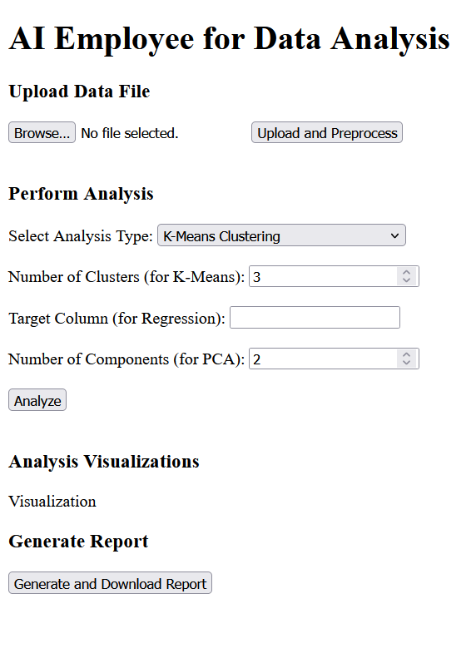

Backend:

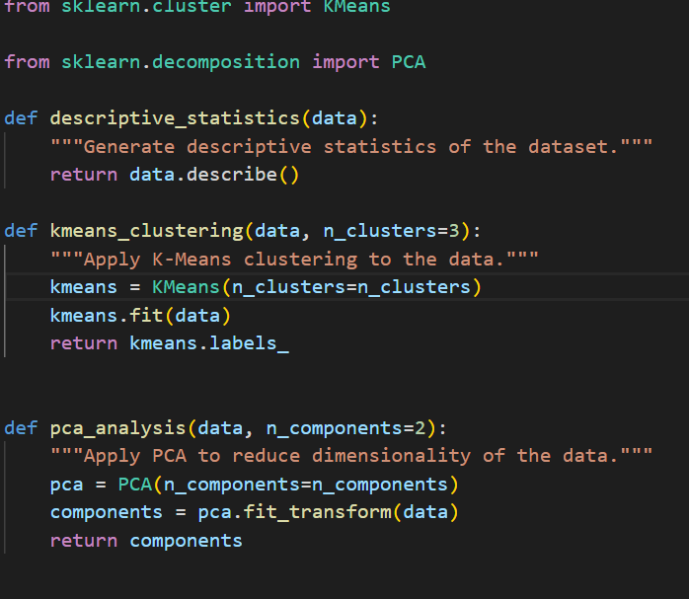

Report Generation:

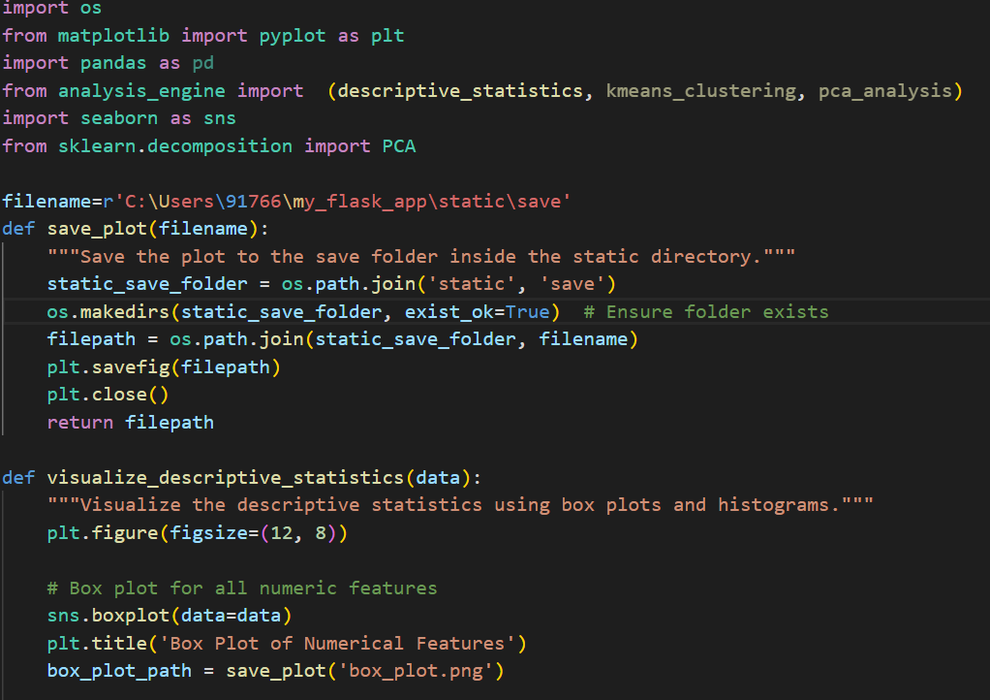

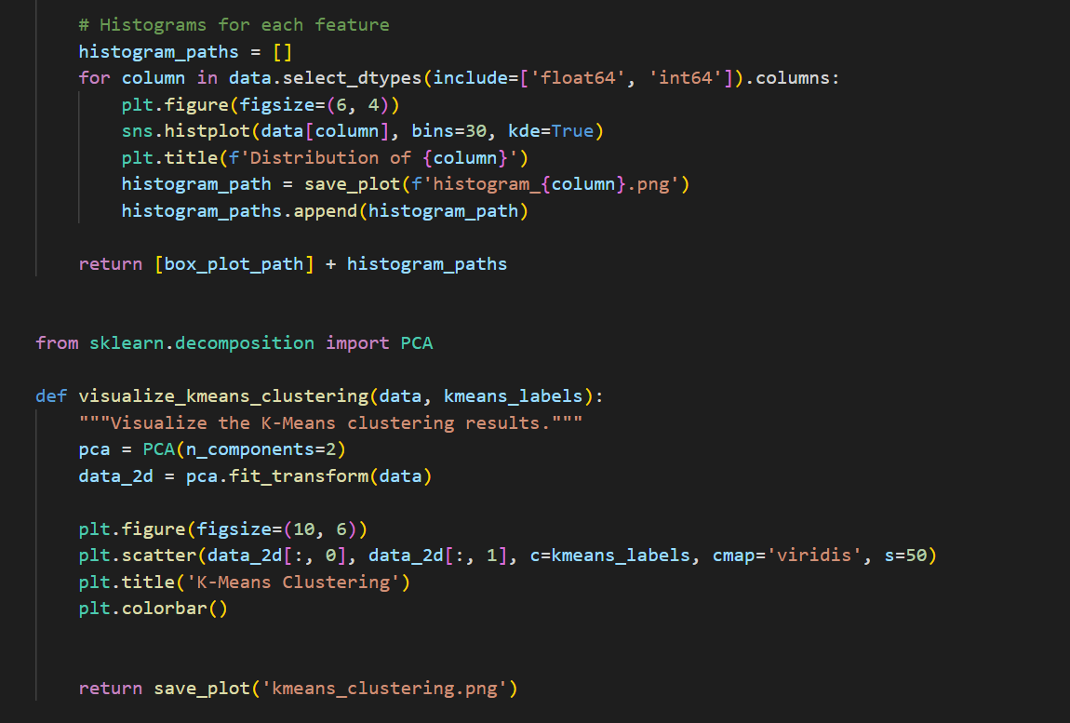

And rest is in my github .bascially this code snipit is only to visualize the data which has already gone through all the above process .

Github : https://github.com/samanta-sumit/ai_dataanalyst_employee

Visualization:

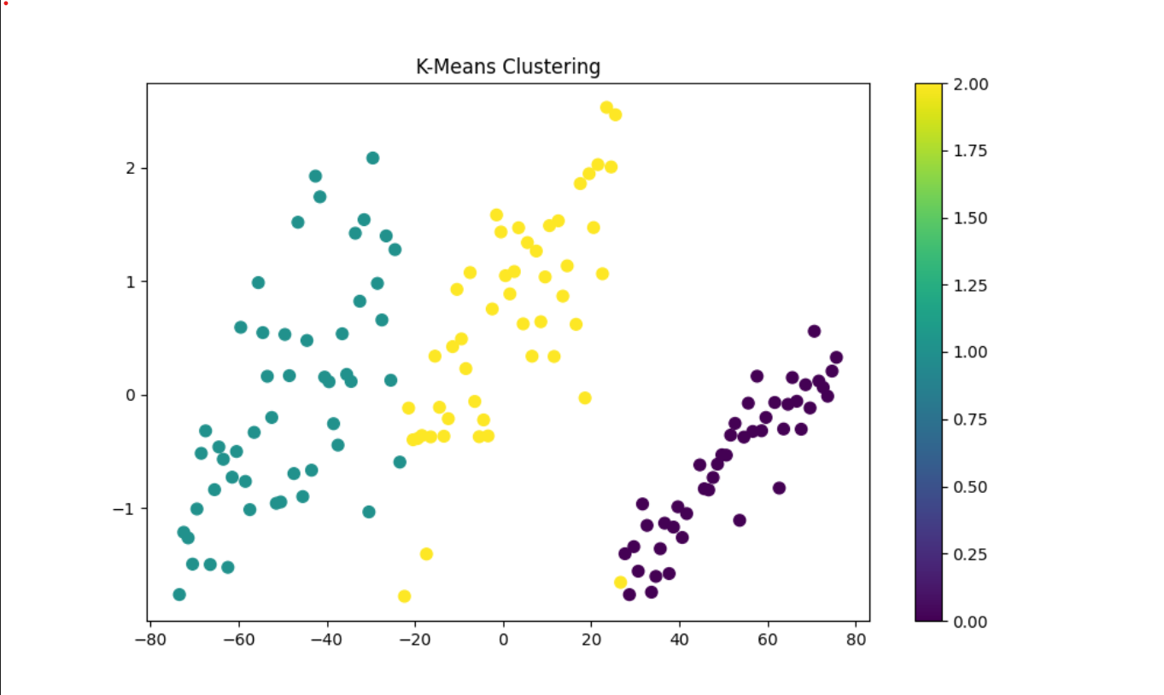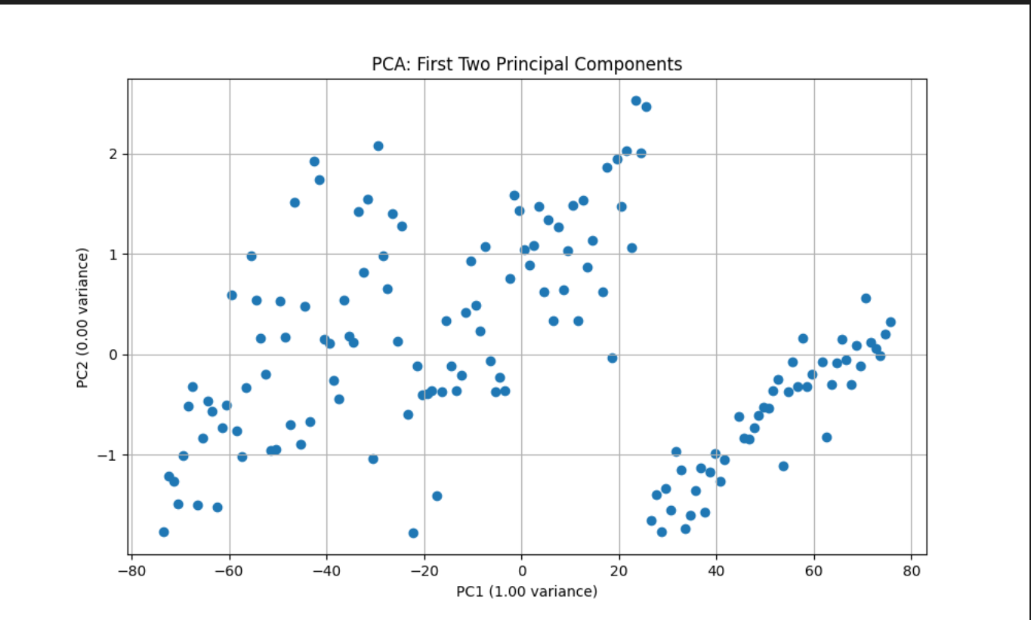

**Work flow:**

Select file to upload

Anlysis

data

Processed

Click on upload and process

Visualization and download of report

**BUISSNESS MODEL**

The Subscription Model is ideal for LocalInsight India as it ensures a steady, recurring revenue stream while providing consistent value to SMEs. By offering tiered subscription plans, businesses can access essential market insights at an affordable entry point, while advanced features like predictive analytics and custom reporting cater to premium users. This model aligns with the needs of SMEs for regular, updated insights to make data-driven decisions without the burden of large upfront costs. Additionally, it fosters customer loyalty and long-term engagement, as businesses will continually rely on LocalInsight India for ongoing market intelligence.

**Subscription Model:**

A **subscription model** is a business strategy where customers pay a recurring fee at regular intervals, such as monthly or annually, to access a product or service. This approach is increasingly popular in various industries, providing businesses with a steady stream of revenue while offering customers continued access to a service or product.

1. **Predictable Revenue Stream**: Subscription models create a consistent and predictable revenue flow for businesses, allowing them to forecast income and plan long-term strategies effectively.
2. **Customer Retention Focus**: Instead of relying on one-time sales, the subscription model emphasizes customer retention by offering ongoing services, regular updates, or new content, which encourages customers to maintain their subscriptions.
3. **Flexible Pricing and Tiers**: Many subscription-based services offer multiple pricing plans or tiers, giving customers the option to select the level of service that best suits their needs and budget. This flexibility enhances customer satisfaction.
4. **Convenience for Consumers**: Subscriptions often automate the delivery of goods or services, making them convenient for consumers. Services like streaming platforms or SaaS applications allow customers to access content or tools anytime without needing to make additional purchases.
5. **Variety of Industries**: Subscription models are applied across various sectors, such as entertainment (Netflix, Spotify), software (Office 365, Adobe Creative Cloud), e-commerce (subscription boxes), and fitness (gym memberships, online workout programs), demonstrating the versatility of this business model.

**PRODUCT DESCRIPTION:**

Our website offers a subscription-based service that provides users with access to a variety of tools and features tailored to different plans. Whether you're looking for basic functionality or advanced insights, our service is designed to meet your needs.

1. **Subscription Plans**: Users can choose from multiple subscription plans, each offering different levels of access to features. Basic plans provide access to essential tools, while premium plans unlock advanced features for deeper insights and greater customization.
2. **Full Access with Subscription**: Once a user subscribes, they will have access to all functions corresponding to their chosen plan, including data analysis, reports, and tools specific to their subscription level. Features are continuously updated to provide the latest functionality.
3. **Advanced Analysis**: For those requiring in-depth analysis, we offer specialized services that go beyond the regular subscription. This can include advanced data breakdowns, customized reports, and other personalized insights. This service will be charged separately.
4. **Consultations and Meetings**: Subscribers who opt for deep analysis will be provided with personalized consultations. Meetings will be arranged as part of the service, allowing users to discuss their needs, get tailored advice, and dive deeper into their data.
5. **Easy Payment and Access**: Payment for subscription and premium services is simple and secure, with options to upgrade or adjust plans at any time. Subscribers can manage their accounts and access all features seamlessly through the website interface.

**Market Analysis:**

LocalInsightAI will initially target small and medium-sized businesses (SMBs) across various industries, including retail shops, restaurants, salons, gyms, and local franchise owners. These businesses often operate in highly competitive environments and require localized insights to make data-driven decisions. The primary market focus will be urban and suburban areas, where customer bases are diverse and the demand for precise, actionable insights is higher. Additionally, the product will cater to SMBs in developing economies, such as India, Brazil, and Indonesia, where businesses are increasingly adopting digital tools to remain competitive. By offering affordable and scalable solutions, LocalInsightAI aims to empower local businesses to understand customer preferences, analyze competitor trends, and forecast market demand effectively.

### ****Operating Plan:****

The operating plan for **LocalInsightAI** begins with building a skilled team that includes one full-stack web developer and 3-4 machine learning engineers with expertise in customer segmentation, sentiment analysis, and demand forecasting. The development process will start with gathering data from local businesses, such as customer demographics and competitor insights, to create a tailored machine learning model. After the model is developed, it will undergo testing, followed by a pilot phase where a few local businesses will try the platform and provide feedback. The final product will be refined based on this feedback before a broader launch.

Pricing will start with an **affordable introductory model** to attract small businesses, with tiered plans based on the size and needs of the business. Advanced features like deep analysis and personalized consultations will be available at an additional cost. Customer engagement will be critical, with regular updates, support, and consultations to ensure satisfaction. The platform will evolve through client feedback and performance data, and as it grows, new features will be added, such as loyalty program integration and competitor benchmarking. Partnerships with local business groups will be explored to expand the reach of LocalInsightAI.

**Financial Equation:**

•Subscription pricing is competitive for analytics tools targeting small businesses is between 500-2500 To keep the rates affordable we can charge 500 for basis and 2000 for advance

• Development costs 15000 initial and maintenance 3000 month reflect typical software development standards for AI-based platforms.

Here for financial equation I am only taking subscription pricing we can afterwards add all the other strategies’ and create a new equation.

• **Assumption**:

* First-Month subscribers: 400(basic)
* Growth Rate: 10% monthly.

The formula for financial equation is :

= product unit cost * total number of sales - cost to produce(per month)

=500 * 400 -3000

=20000-3000

=17000

So ,

Y = 500x-3000

This would be the financial equation per month .